Help Writing Scripts

A good place to start is with the Demo projects on the Tab bar next to the Current Project panel.

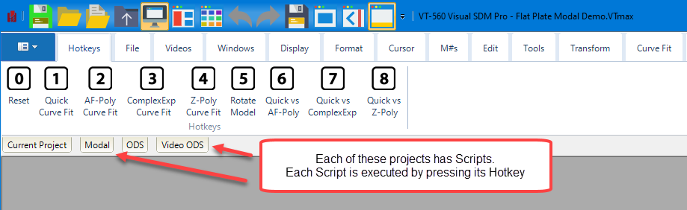

The Operating Manual describes how to create Scripts. It is available from within MEscope and is also available on the Vibrant website.

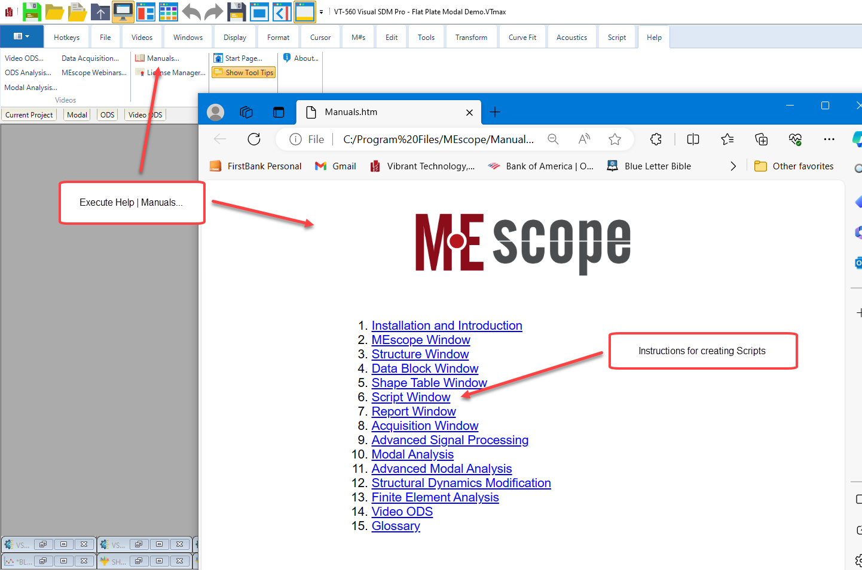

Scripts can also be copied from other projects into the Current Project by using the Add command in a right-click pop-up menu next to a Script file in another Project.

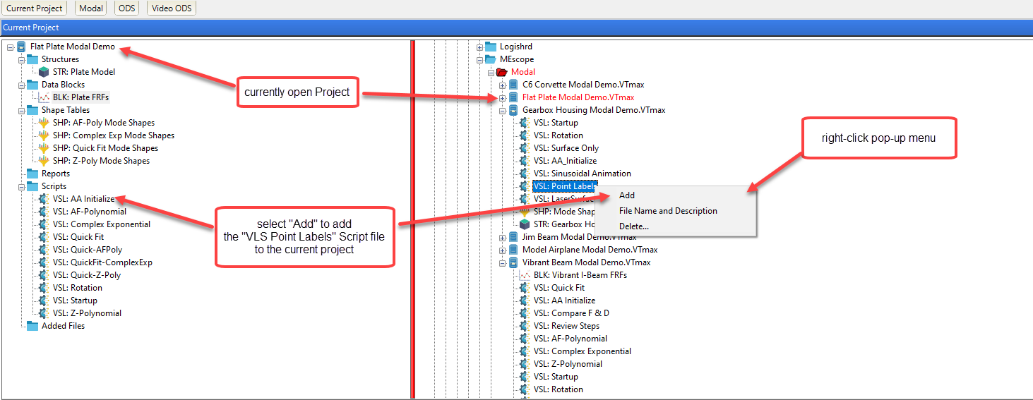

If you need further help writing a Script, if you send Vibrant a project with your Script in it, we can help you.

